Dear Parent / Carer

Re: Free School Meals and Pupil Premium

If you are in receipt of financial support from the government, or your income is below a specified threshold even if you do not receive any income support, your child is likely to be eligible for free school meals, meaning they will be allocated a certain amount of funding per day to purchase food from the canteen.

Additionally, we’ll receive extra funding called ‘Pupil Premium’ for every child who is registered as ‘free school meals’. We use this extra money to improve the educational provision and resources at the school. This extra money could make a real difference to the quality of education we offer. You may wish to review how we use this additional funding by reading our pupil premium statement on our website. This means that even if you do not want to use your child’s free school meal entitlement, you should still apply.

Is my child eligible for free school meals?

Your child might be eligible if you access:
- Income Support
- Income-based Jobseeker’s Allowance or Employment and Support Allowance
- Support under part VI of the Immigration and Asylum Act 1999
- The guaranteed element of Pension Credit
- Child Tax Credit (provided you’re not also entitled to Working Tax Credit and have an annual gross income of no more than £16,190)
- Working Tax Credit run-on
- Universal Credit, provided you have an annual net earned income not exceeding £7,400 (£616.67 per month)

You will be eligible to apply for this if you have fallen into this category for even 1 day over the last 6 years.

If you are not eligible for any income-related government support, because of (for example) your immigration status, you may still be eligible for free school meals if you are working, but earn below:
• £22,700 for families with 1 child
• £26,300 for families with 2 or more children

How do we use Pupil Premium Funding?

Pupil Premium Funding benefits every child in school, but specifically those who’s families are eligible. Within school this year we have used some of our funding to:

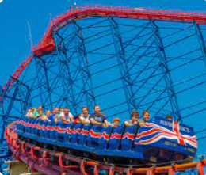
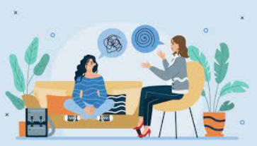
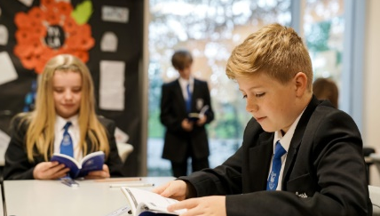

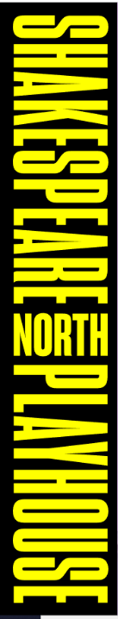

Reduce our class sizes.
Employ two school based counsellors.
Reduce the cost of reward trips.

Ensure children in every year group have had access to events at the Shakespeare Playhouse.

How do I register?

If you believe that you may be eligible but are not in receipt of free school meals, please complete the relevant form.
If you are a Knowsley resident: https://parentportal.knowsley.gov.uk/web/portal/pages/fsmapplication#h1
If you are a Liverpool resident: https://liverpool.gov.uk/benefits/free-school-meals/

Support to complete paperwork is available in school. If you have any further questions, please contact Mrs Earps Assistant Principal Inclusion and Safeguarding on eearps@prescotschool.org.uk.

Yours sincerely

Mrs G Cousineau
Head of School

