Literacy Lessons at The Prescot School

At the Prescot School, we follow a reading development programme to support pupils with weaker Literacy skills in order to target gaps in learning as they emerge to ensure secure reading progress. Your child’s reading age will be tested at the beginning of each academic year, and if this identifies a reading age lower than your child’s chronological age, they will be offered targeted literacy lessons each week. The programme improves pupils’ comprehension, reading fluency and automaticity – their ability to recognise high frequency words quickly.
*If your child is taking part in the reading development programme, you
will be notified by our literacy lead.

An example of a reading programme session:
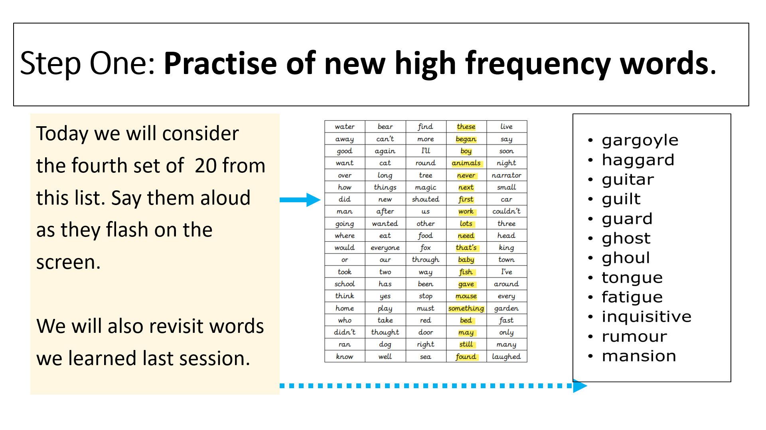
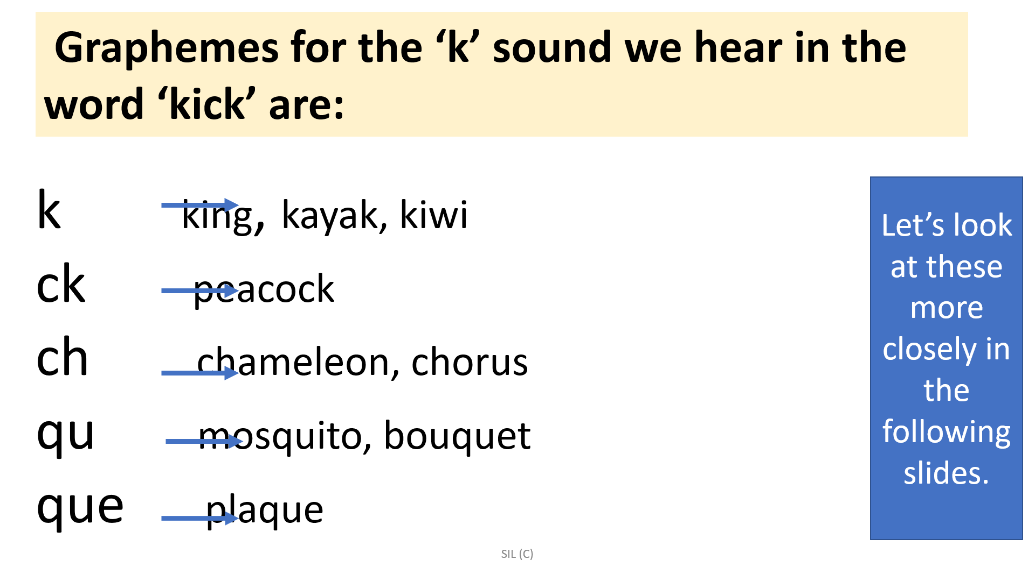

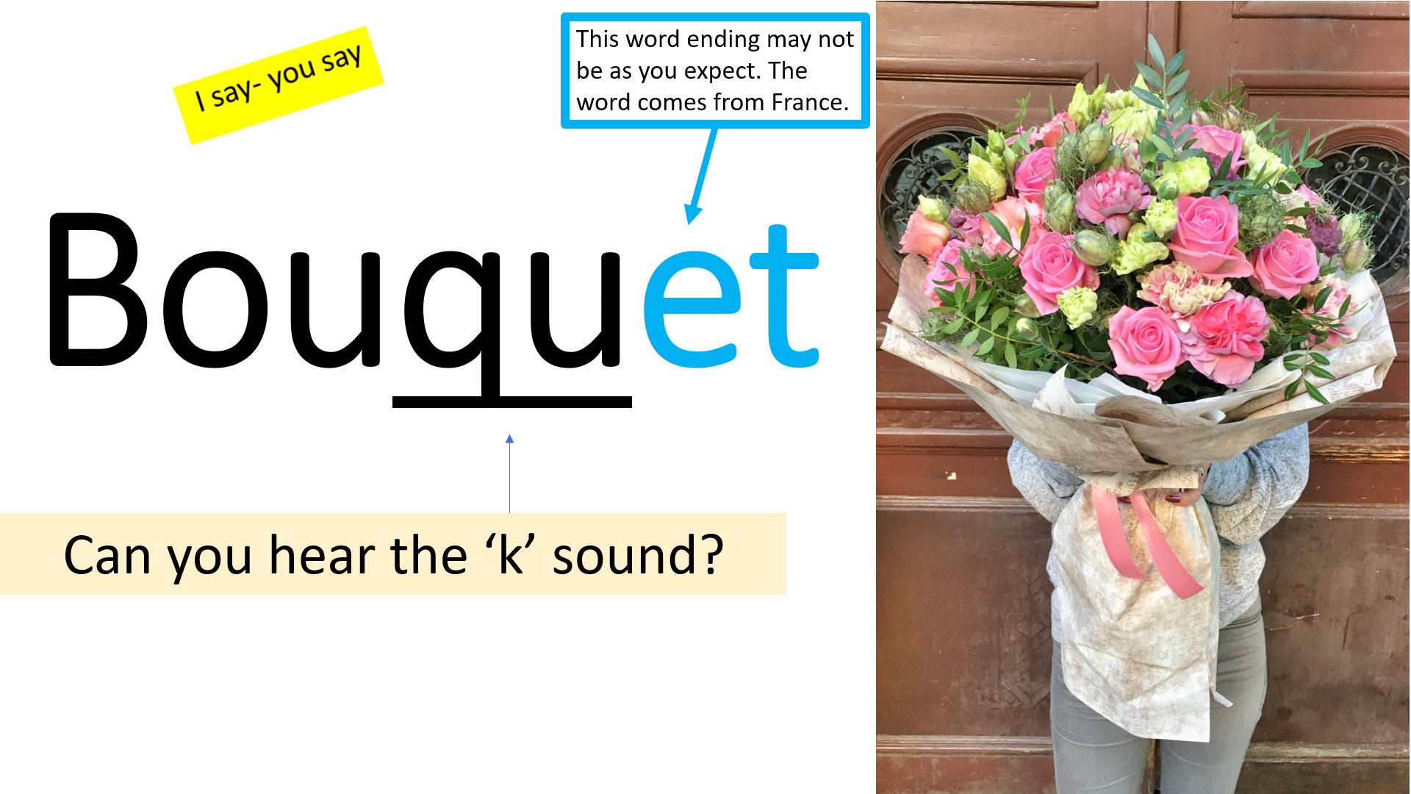

What is Lexia?
This scheme aims to close gaps in pupils’ literacy skills. This is a computer based scheme that can be accessed in school and at home. It works on weak phonic skills taking pupils back to basics and progresses to support pupils’ spelling, reading and grammar skills.
Pupils are tested on their Literacy skills in a fun and engaging way. This allows them to feel confident and relaxed whilst they are learning.
Your child’s teacher will have access to data and their progress each week. This means we can praise your child efficiently when they are doing well and put interventions in place where necessary for support.
Who has access to Lexia?
At the Prescot School, we use Lexia to support pupils with weak Literacy skills in order to target gaps in learning as they emerge in order to secure progress.
*If your child is taking part in the lexia programme, you will be notified by our literacy lead who will provide you with log in details.


Access at home: Lexia is really accessible at home and can be used on most home devices e.g. tablets/phones. You can support your child with Lexia by encouraging them to complete 30 minutes of Lexia each week on their home devices.
You can access Lexia using the following link:
https://www.lexiapowerup.com/

