How can I help my child with their spelling?
Why is spelling important?
Lots of people worry about making spelling mistakes; learning and practising spellings take time but can help with your child’s reading and understanding of a text. Being a competent speller will also help your child thrive when writing e.g. creative stories.
Spelling at The Prescot School:
At the Prescot School we adopt the look-say-cover-write-check model when practising our spellings. Every week your child will be given a list of 10 words to learn. (The spelling words for each week can be found in their SKO booklet). Your child will then be tested in lesson the following week and their progress will be monitored regularly by their class teacher. In order to ensure that your child makes progress with their spellings we have designed a programme that reinforces everyday basic vocabulary; as well as encouraging your child to use challenging and inspiring words to increase their repertoire.
The spelling lists look like this:
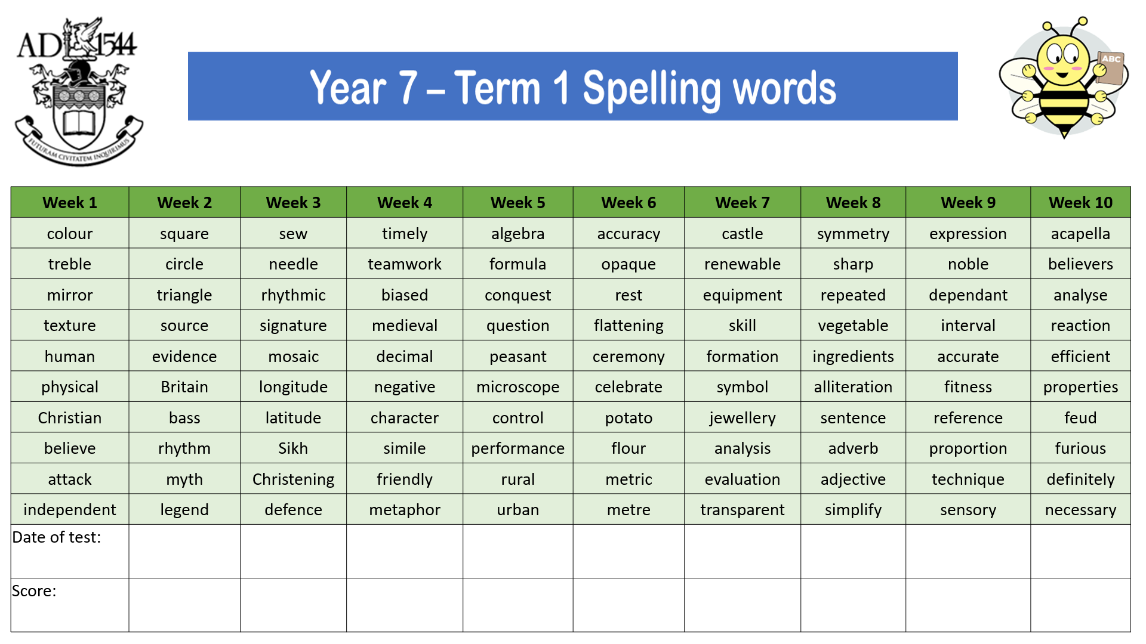

Advice and guidance on how to support spelling at home:
- Read the lists of spellings out loud to your child.
- Contextualise the words matching the definitions to the words. It is important that children understand what the word means. Ask your child:
- What does that mean? o What is a ____?
- Can you think of a synonym (alternative word)?
- Check which words your child already spells correctly, these are low priority words.
- Look at any problem words one at a time, practise spelling them aloud and looking at the shape of the word with your child before writing them down.
- Follow the model: look at word, say the word out loud, cover the word, write it down – check the spelling.
- Encourage your child to write the word in a sentence and check that it makes sense. This will allow you to determine if they understand the meaning of the word or need further input.
- Praise their efforts.
- Work in shorts bursts; 10-15minutes at a time is plenty.
Spelling Bees:
- If your child is in KS3- they can enter our termly Spelling Bee competitions. They will represent their form class in a friendly competition. This is a fun way to encourage your child to engage with their spelling words.
- All pupils who participate will be rewarded with spelling bee badges and the winning form class will receive a trophy to display in their form room.
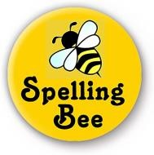
- Encourage your child to participate and help them to prepare for the Bee by practising their weekly spellings with them.

