Reading Record

Your child has a Reading Record page within their SKO’s where they should record any ‘reading for pleasure’ that they complete outside of their usual lessons. This could be a book, a news article, a magazine, a poem…anything that holds their interest.

An example of the Reading Record:

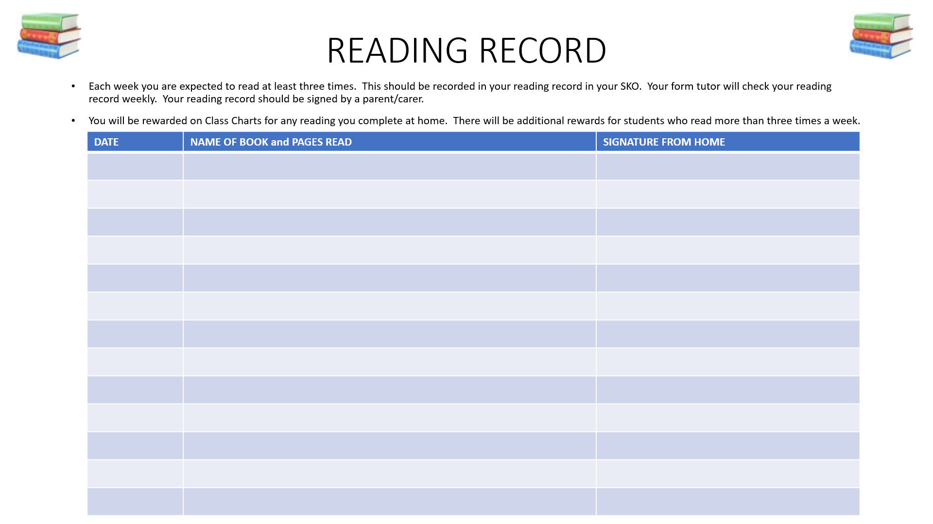

By encouraging your child to read at home you will be helping their vocabulary acquisition, fluency of reading and automaticity. All of which will benefit your child in every subject across the curriculum as they progress from KS3 to KS4 and beyond.

