
Supporting Literacy development at home:
Reading.
Spelling.
Writing.
Oracy and Communication.

Contents:
2 | Developing Literacy at home
3 | Reading
8 | Spelling
10 | Writing
12 | Supporting your child with homework



Developing Literacy at home

Encourage different types of
reading: magazines,
websites and reference
books are all valid reading
materials.

Buy books and other
reading materials as
presents.

Promote good
reading behaviours
by reading often
and discussing
books with your
child.

Encourage everyday reading and
writing, e.g. making shopping lists,
sending emails and cards to highlight
the importance of reading in
everyday
life.

Listen to audio books;
discuss the events of
the story and how it is
told.

Encourage older
children to read
with younger
siblings and family
members

How can I get my child to read? 
Why is reading important?
Reading is the key to successful learning. The ability to read and understand a text underpins effective communication at all levels. It is a crucial skill that impacts on all elements of a person's life and learning. Reading widely is very important: newspapers, magazines, instructions, leaflets are all examples of different types of reading.

It is crucial that your child’s reading age is in line with their chronological age.
For example, if your child is 12 years old- it is important that their reading age is 12 years old or +. This will ensure they can confidently access and engage with age appropriate reading materials.

- In a modern world, where life is fast paced and so very busy- reading is a great opportunity to switch off from typical, everyday life and bond with your child. Engaging in exciting dialogue about characters and key events.

- Reading enhances your child’s critical thinking and inference skills. When you read a book you make predictions about the characters and what is going to happen next. This challenges your child’s brain to think about other possibilities based on their knowledge and understanding of the story so far.

- Recounting key events and remembering what has happened previously in a book boosts your child’s memory skills.

- Reading is a great way to discover and make sense of the world around us. Children get exposed to ideas and beliefs from different cultures and countries. It opens their minds to realities other than their own.

- Reading at home prepares your child for further education at KS5 and life beyond the classroom in a workplace setting.
Advice: Talk about books with your child:
- Before reading discuss: the cover (author, pictures, title), make guesses about what books is going to be about.
- During reading: make previous connections to events or ideas; think about why the writer has organised them in this way; make predictions about what comes next.
- After reading: rate the books, think about whether it met expectations; which parts were successful; was the ending as you expected.

Reading to your Child
Reading to your child does not make them lazy! It allows them to understand how to read fluently and effectively; it also shows them that you value reading.
Read what you are comfortable with. Your child may have outgrown you reading books to them, but reading sections from the newspaper, a recipe or sections from a website, will allow them to understand that reading aloud does not stop.

At The Prescot School, all pupils will have thirty minutes of guided reading time
each week, within their form classes. The reading material is varied, engaging
and appropriately challenging for each year group.

Within the home the expectation is that all students should read for a minimum
of twenty minutes daily. The more a student reads, the more confident and
competent they will become.

Questions to ask your child when reading a book:
• | Are you enjoying this book?
• | Can you tell me what has happened so far?
• | Where is the story set?
• | Is this a fiction or non-fiction book? How do you know?
• | Who is your favourite/least favourite character?
• | What is your impression of ____ (Character’s name)?
• | How did you feel about ___?
• | Can you imagine if that happened to you? What would you do?
• | Why did that happen?
• | Why did ____ behave/react like that?
• | What do you think will happen next?
• | Who is the author of the book?
• | Can you do some research about the author?



Reading in different places:

- Reading is everywhere! For example: leaflets at the doctor’s surgery, road signs, advertisements.
- Encourage your child to read and discuss online news articles with you.
- Read outdoors: in a park or garden.
- Discuss the purpose and meaning of different types of reading.

Follow the 7 top tips to supporting reading at home:
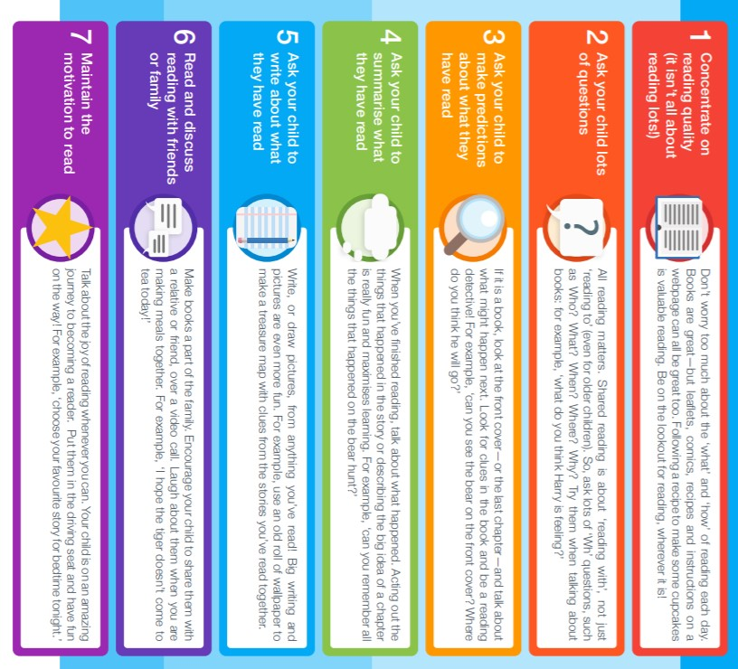



Extending Lexia at home: 
What is Lexia?
This scheme aims to close gaps in pupils’ literacy skills. This is a computer based scheme that can be accessed in school and at home. It works on weak phonic skills taking pupils back to basics and progresses to support pupils’ spelling, reading and grammar skills.
Pupils are tested on their Literacy skills in a fun and engaging way. This allows them to feel confident and relaxed whilst they are learning.
Your child’s teacher will have access to data and their progress each week. This means we can praise your child efficiently when they are doing well and put interventions in place where necessary for support.
Who has access to Lexia?
At the Prescot School, we use Lexia to support pupils with weak Literacy skills in order to target gaps in learning as they emerge in order to secure progress.
*If your child is taking part in the lexia programme, you will be notified by our literacy lead who will provide you with log in details.


Access at home: Lexia is really accessible at home and can be used on most home devices e.g. tablets/phones. You can support your child with Lexia by encouraging them to complete 30 minutes of Lexia each week on their home devices.
You can access Lexia using the following link:
https://www.lexiapowerup.com/
How can I help my child with their spelling?
Why is spelling important?
Lots of people worry about making spelling mistakes; learning and practising spellings take time but can help with your child’s reading and understanding of a text. Being a competent speller will also help your child thrive when writing e.g. creative stories.
Spelling at The Prescot School:
At the Prescot School we adopt the look-say-cover-write-check model when practising our spellings. Every week your child will be given a list of 10 words to learn. (The spelling words for each week can be found in their SKO booklet). Your child will then be tested in lesson the following week and their progress will be monitored regularly by their class teacher. In order to ensure that your child makes progress with their spellings we have designed a programme that reinforces everyday basic vocabulary; as well as encouraging your child to use challenging and inspiring words to increase their repertoire.
The spelling lists look like this:
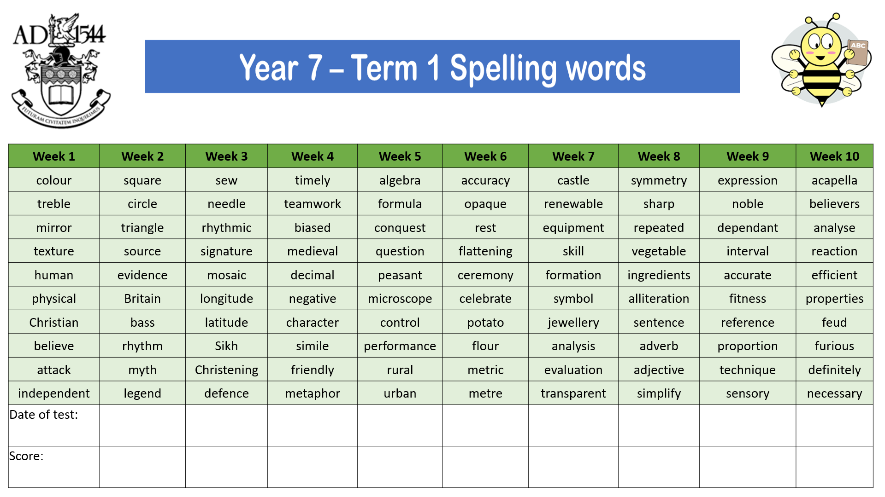

Advice and guidance on how to support spelling at home:
- Read the lists of spellings out loud to your child.
- Contextualise the words matching the definitions to the words. It is important that children understand what the word means.
Ask your child:
  - What does that mean? o What is a ____?
  - Can you think of a synonym (alternative word)?
- Check which words your child already spells correctly, these are low priority words.
- Look at any problem words one at a time, practise spelling them aloud and looking at the shape of the word with your child before writing them down.
- Follow the model: look at word, say the word out loud, cover the word, write it down – check the spelling.
- Encourage your child to write the word in a sentence and check that it makes sense. This will allow you to determine if they understand the meaning of the word or need further input.
- Praise their efforts.
- Work in shorts bursts; 10-15minutes at a time is plenty.
- Do random spelling checks to ensure your child is retaining the information.
Opportunities for your child in school that you can support with:
- Ask your child about their spelling test scores in school.
- Encourage your child to convert their test score into a percentage so that they can see how much progress they are making on their journey.
- If your child is in KS3- they can enter our termly Spelling Bee competitions.

- Encourage your child to participate and help them to prepare for the Bee by practising their weekly spellings with them.

How can I help my child with their writing?
Why is it important to encourage writing?
Children who find reading difficult, will find writing even harder. Much of your child’s ability throughout their school journey is tested through what they can write down. Therefore, it is important that your child feels confident when writing for a variety of purposes, register and genres.

Writing

Purpose:

Inform

Persuade

Entertain

Register:

Formal

Informal

Genre:

Article Letter

Report Speech

Review Essay Creative story

Writing encourages your child to:
- Determine how to communicate effectively and successfully.
- Develop critical thinking skills.

- Develop creativity and imagination.
- Develop a strong sense of self.
- Develop organisational skills.
- Practise spellings.
- Increase vocabulary.
- Proof- read and check sentences make sense.
- Prepare for exams.
- Prepare for life beyond school: Further education/work setting.

Advice: Writing tasks at home that can support your child’s progress.
  - Encourage your child to write for a variety of purposes:
    - Handwritten shopping lists. o Quick notes to you.
    - Telephone messages are examples of written communication which can be used daily.
  - Encourage your child to communicate with people using written communication, like emails.
  - Encourage your child to write diary entries.
  - Encourage your child to start online blogging about a hobby or interest with your supervision.
  - Encourage your child to research and write a biography about a person of interest.
  - Start a scrap book and get your child to write little descriptions of places they have been.
  - Cut out images from magazines/leaflets/articles and ask your child to write about what is happening in the image.
  - Create story boards and short stories- pay attention to describing key characters and events.
  - Write letters to distant family members and friends- share exciting information with
  - Praise the writing your child does before making any suggestions for improvement.
  - Remember, the key to being a successful writer is to be a successful reader!


How can I help my child with their homework?
Why is homework important?
Literacy underpins all aspects of communication; reading, writing and oracy.
This is applicable to ALL subjects across the curriculum; as well as homework. Homework is provided as an extension to in school learning. Regularly access your child’s Class Charts account and visit the ‘my homework calendar’ section to see what has been set and the date it is due.

At the Prescot School, your child is encouraged to engage with a Subject Knowledge Organiser (SKO), as part of their weekly subject homework. This consists of learning key terminology, definitions and examples linked to a particular topic and scheme of work.
An example of an SKO can be seen below:
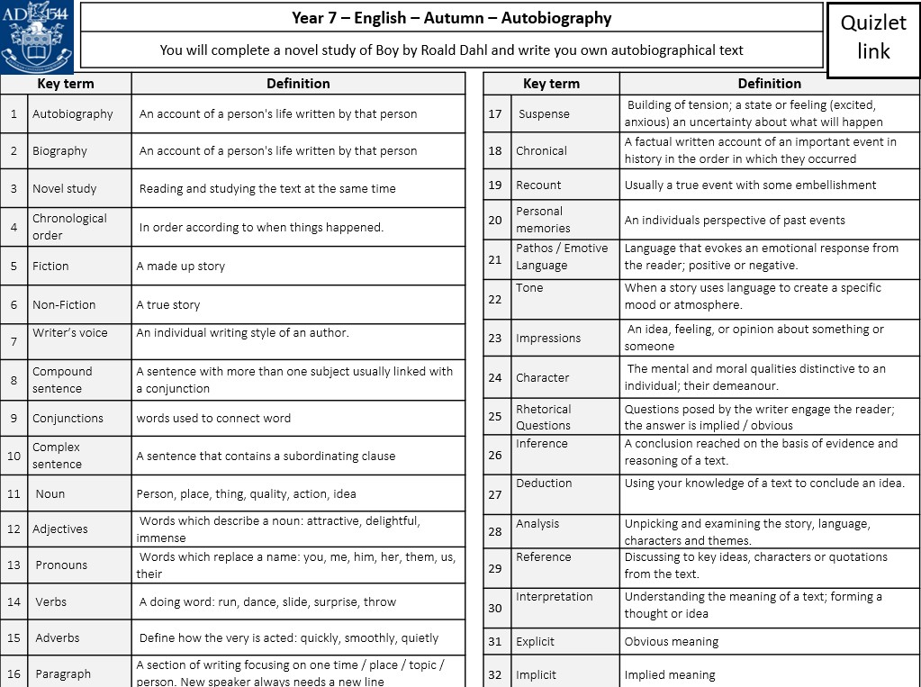

Having regular discussions about your child’s homework and encouraging them to learn key terminology will help to secure knowledge and understanding of a topic. You can support your child at home by regularly testing them using the SKO and monitoring their Quizlet scores.

Advice: Developing a homework routine.
- Choose a suitable homework time which fits with both you and your child.
- Choose a suitable place for your child to complete homework.
  - Is it a quiet place?
  - Is it comfortable?
- Make sure homework isn’t left until the last minute.
- Make sure your child is clear about the homework they have been set – you can check this on ‘Show My Homework’ on Class Charts.
- Ensure your child has suitable equipment, e.g. pen, pencil, paper.
- Encourage your child to do their homework themselves, offering suggestions and support where needed.
- Praise your child’s efforts where appropriate.
- If you have any worries contact your child’s teacher and discuss your concerns further.

Should you wish to contact your child’s teacher further; it is best to do
so via the school office or through the school email system: info@prescotschool.org.uk
We strive to answer any communication within 2 working days.


